Just Coders



17 November 2021 Mr. Ephraim

PROJECT WEBSITE USER SUPPORT DOCUMENT

**Inside Cover Page**

* **Number of the team**
* DISD313 Group 4, with 3 members
* **Name of the team**
* Just Coders
* **Name and student number of team leader**
* Vusimuzi Mphela 17608576
* **Names and student numbers of team members**
* Given Mnguni 18011644
* Ntandoyenkosi Ndaba 16011865
* **Name and logo of the system**
* The Ben Luc System



Table of Contents

1. Introduction3
2. System requirements…………………………………4

2.1 Change Ip address information………………….5

1. How to compile and start shopping……………8
2. Conclusion……………………………………………….11

# Introduction

The document is a guideline of how to compile the Ben Luc system android application, the document highlights some of the minimum requirements that the person who wants to interact with the android application must meet, the document serves as a guideline on how a customer can interact with the android application the most efficient methods to get maximum performance and efficiency from the android application.

When the document is followed accordingly then the android application will provide the user/customer with a shopping experience like no other.

# System Requirements

* Please Note that for the android application to function/compile or execute efficiently on a computer device, the computer device must have all the requirements defined below, failure to meet the requirements outlined below may result in the android application malfunctioning/crashing and giving incorrect/unexpected results.

Hardware resources needed to COMPILE the Ben Luc System WEBSITE

* 5GB of device storage
* Minimum 2.0hz dual core processor
* Minimum 4GB of memory (RAM)
* Minimum 500MB Video dedicated memory (graphic card)
* A computer device.

Software resources needed to COMPILE the Ben Luc System WEBSITE

* A computer that has installed a windows operating system.
* Minimum windows 10 Home edition operating system.
* Android studio 2020 Arctic fox version installed on the computer.
* The computer device must be connected to the internet to successfully compile and execute the android application.

# 2.1 Change Ip address information

- This section is crucial to seeing the android application compile successfully on the android studio 2020 Arctic Fox version so please start here before compiling the android application on android studio, the steps below will guide you on how to change the Ip address connection string of the android application.

Step 1(extract android application project)

* First extract the android application zipped folder to your computer C drive following the path below

C:\Users\Vusimuzi

* Your path might be different than the one above, extract the project anywhere in the Desktop or studio projects inside your C drive, the last component of the path above is computer user’s information, extract the android application on the folders that are inside that folder.

Step 2 (open command prompt)

* Open command prompt on the computer device, the computer device must be connected to the internet to complete this step, inside the command prompt window of the computer device type the words ‘ipconfig’ and click enter as depicted by the pictures.

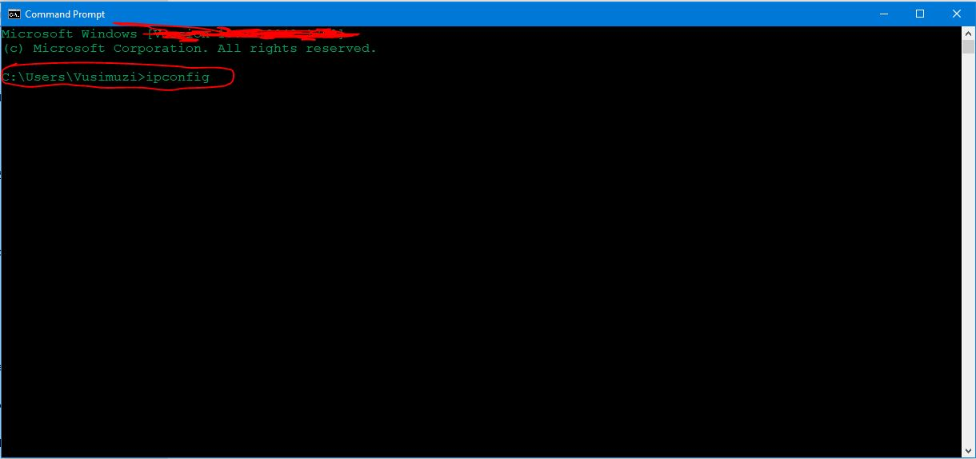

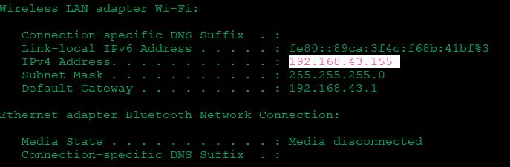

* After typing the phrase ‘ipconfig’ in the command prompt window of the computer device and clicking the enter button, you should search for the section of Wireless LAN adapter WI-FI as depicted by the second picture above, the user should copy the highlighted Ip address on their computer device that is aligned with the IPv4 Address as shown by the second picture above.
* After copying the Ip address as stated above, open android studio and open the android application project that you have stored in your C drive following the path outlined and elaborate better in the section below this one.
* Paste the Ip address in the register java class of the android application and paste the Ip address in the Main-Activity java class of the android application just as depicted by the pictures below.

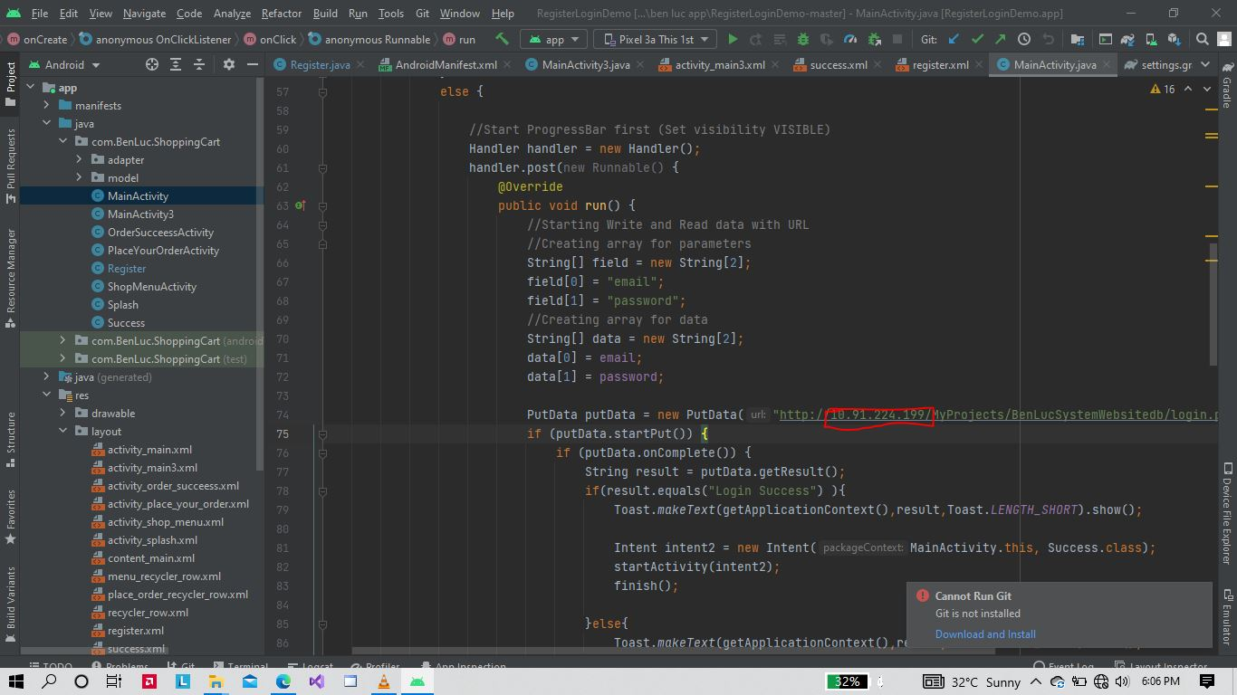

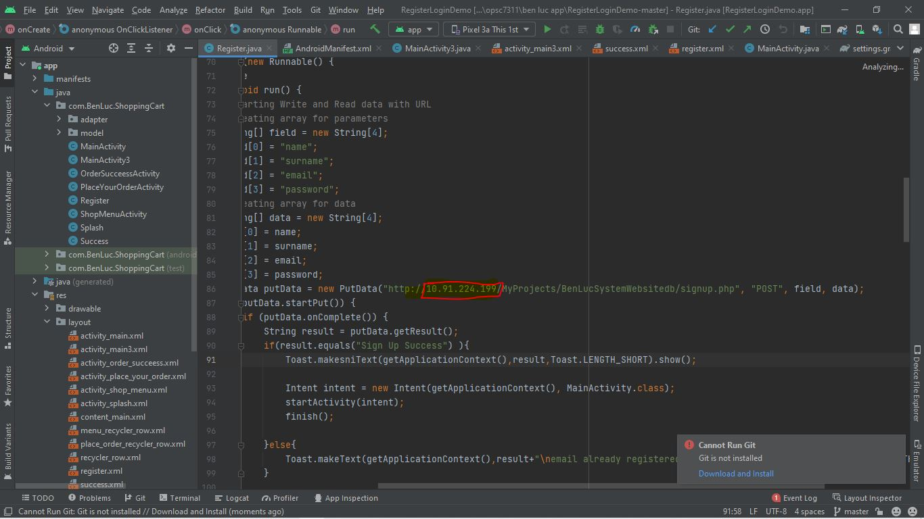

* After pasting the Ip address in the Main-Activity java class of the android application and the register java class of the android application, the user must save the project to synchronize the project files with Gradle.
* After that the user can compile the android application and it will communicate efficiently with the Ben Luc System Database to be able to retrieve and store user account credentials. Please note that when the operation is successful you can use the account credentials you have registered in the Ben Luc system website to login also in the android application.

# How to compile and start shopping

* In this section I will be explaining step by step methods of how to compile the Ben Luc system’s android application, this guideline will start with were to save the project to compile it successfully and it will guide the user until all the different sections of the android application are explored.

1. **Step 1 (project location)**

* To successfully compile the project, the project must be stored in the c drive of the computer device that the user/customer will use to compile the website system. The android application folder can be stored in the Desktop folder inside the C drive or in the studio Projects folder inside the C drive.

1. Step 2 (compiling the android application)

* The user must open android studio 2020 version Arctic fox to compile and run the android application, the user must start the emulator to see the android application display output.
* After the user compiles the project in android studio the user will see the following pictures below, these pictures depict the different features that the user interact with when the android application has successfully compiled on android studio.

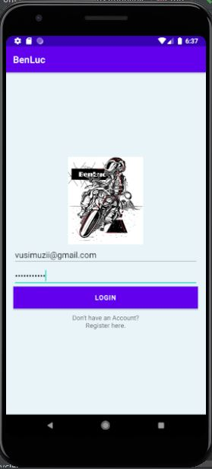 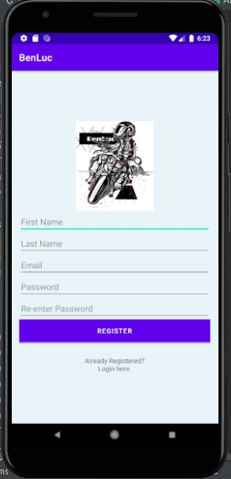 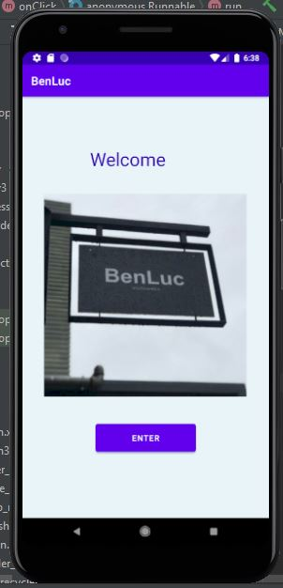

* The pictures above highlight the features of logging in, registering an account and the first screen that the user will see after successfully logging, please note that the android application must be executed while the computer device is connected to the internet otherwise the user will not be able to create an account with the application or login successfully because the android application will not be able to communicate with the database.
* After the user sees the first screen after login the user must click the ‘enter’ button to move to the next screen of the android application, the pictures below depict the features that the user will interact with after successfully logging into the android application.

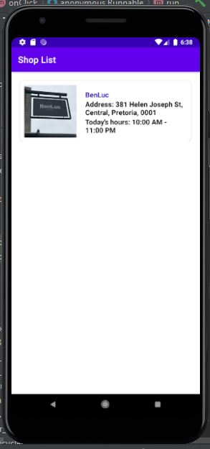 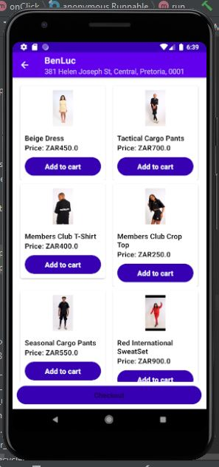

* The user will see the screen on the far left first before they can shop for their favourite clothing items, the user must click the Ben Luc logo on the screen to be directed to the ‘shop’ page where the user can place to cart clothing items that they want.
* After the user has seen the ‘shop’ page the user can click the add to cart button as depicted by the picture on the right above. The user then clicks the checkout button to choose their payment method for creating an order with the android application of the Ben Luc System.
* The pictures below depict the features that the user will interact with after clicking the ‘checkout’ button on the shop page.

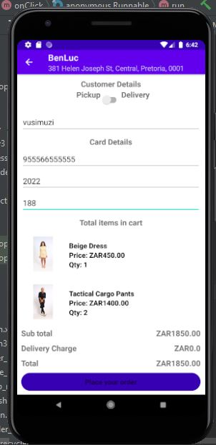 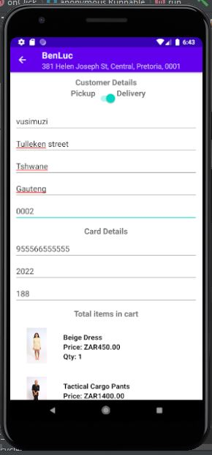

* The user can choose to create an order by selecting the pickup option or by selecting the delivery option the 2 pictures displayed above.
* When the user has chosen their method of payment the user must click the ‘place order’ button to place an order for their selected clothing items on the android application.

# Conclusion

This document was correct at the time it was compiled, if the user of the system follows the guidelines identified above then the user should have a smooth experience using the android application. Should any errors or confusion arise contact Vusimuzi Mphela of the group 4 team.